## Q.1. Create a pipeline name 'Ingestion_Customer_SQLDB_ADLS' which will copy all the records from Customer table to ADLS account as CSV File.

Solution:- As Dataset & Linked List I already created for source and destination. So, connecting customer sql db to source and IN sink connecting ADLS location dataset for destination.

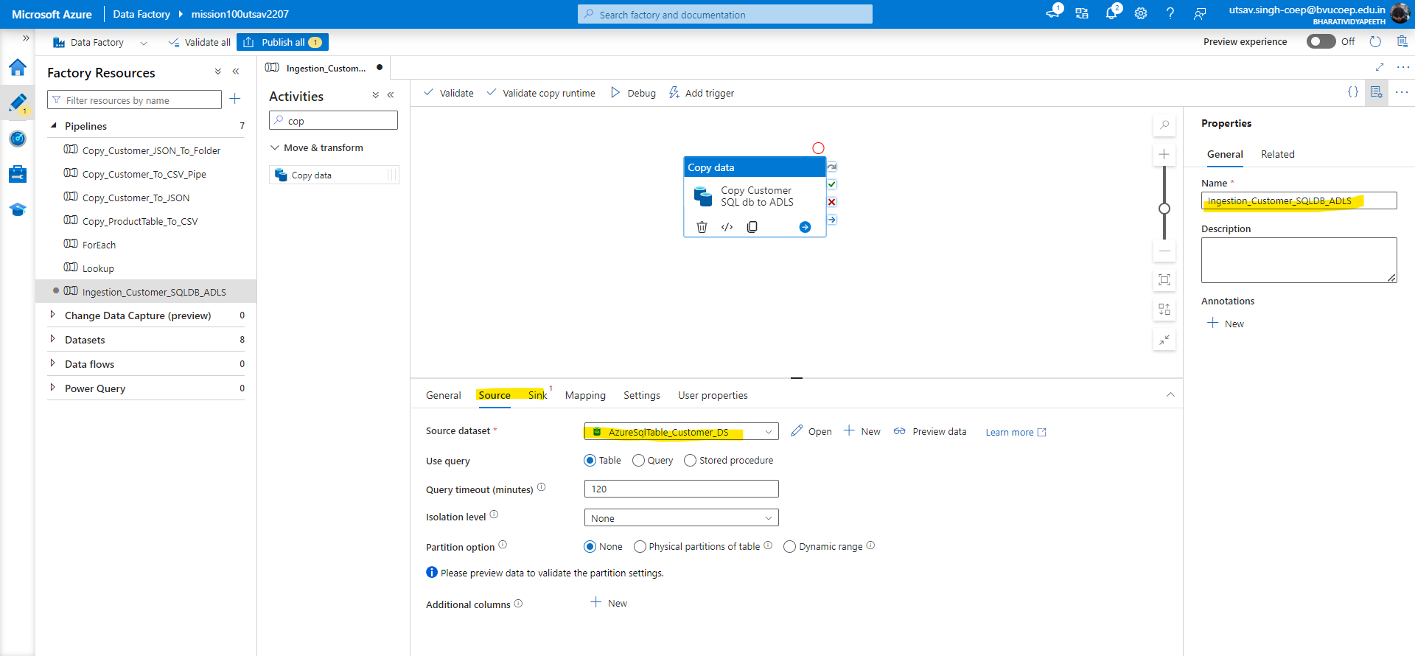

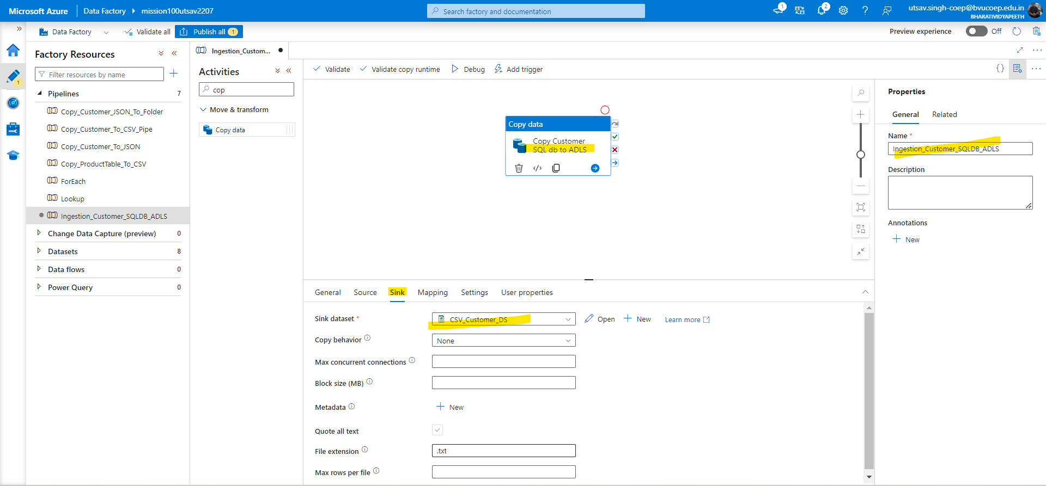

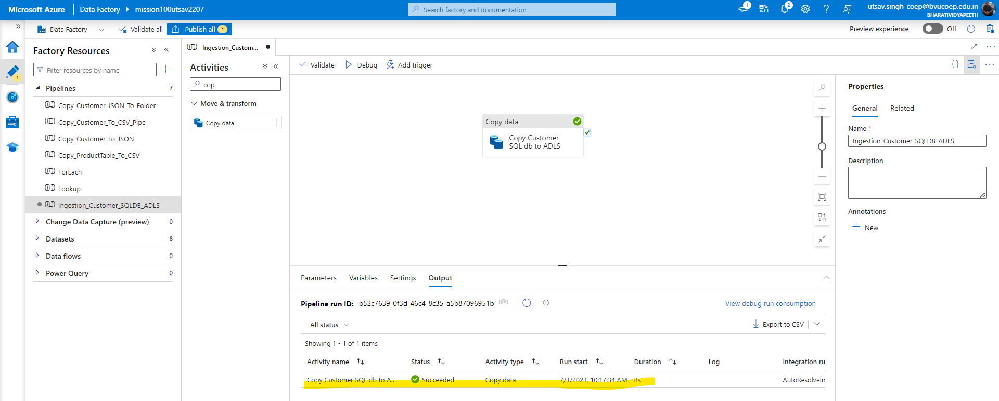

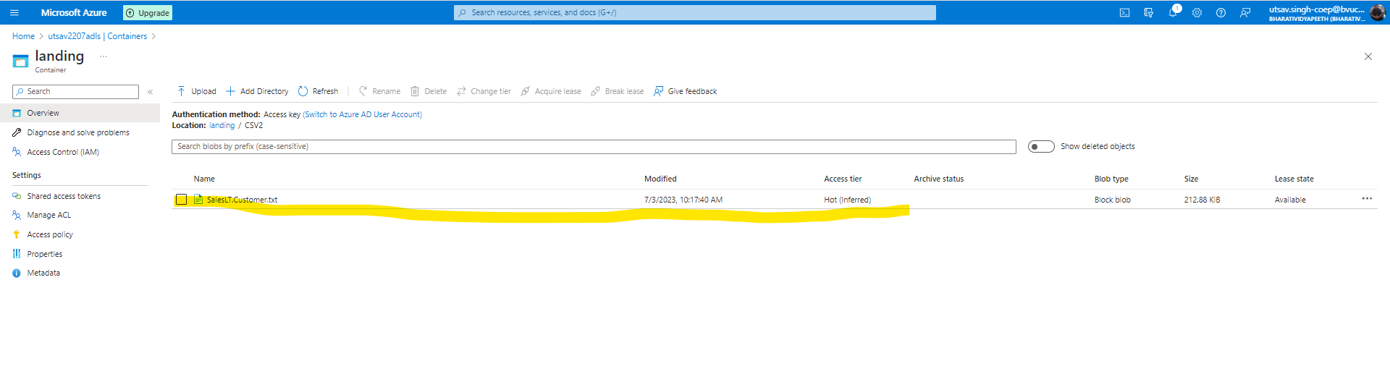

## Q 2. Create a pipeline name 'Ingestion_Customer_SQLDB_ADLS_Folder' which will copy all the records from Address table to ADLS account inside the 'Address' folder as CSV File.

Solution:-As already linked Service is created for source and destination. So, we will create Generic Dataset of Address table for source and destination.

1.First we will add new parameters for schema and table name.

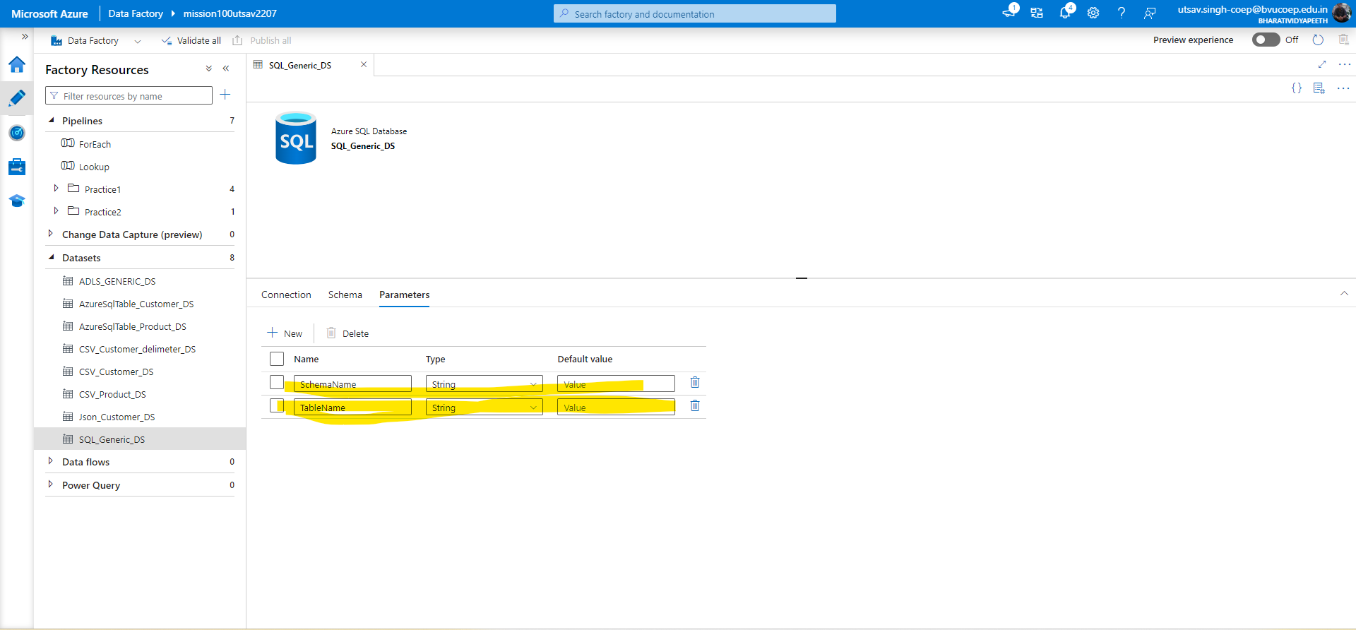

2. Then choose dynamic schema & tablename from connection tab under the table section.

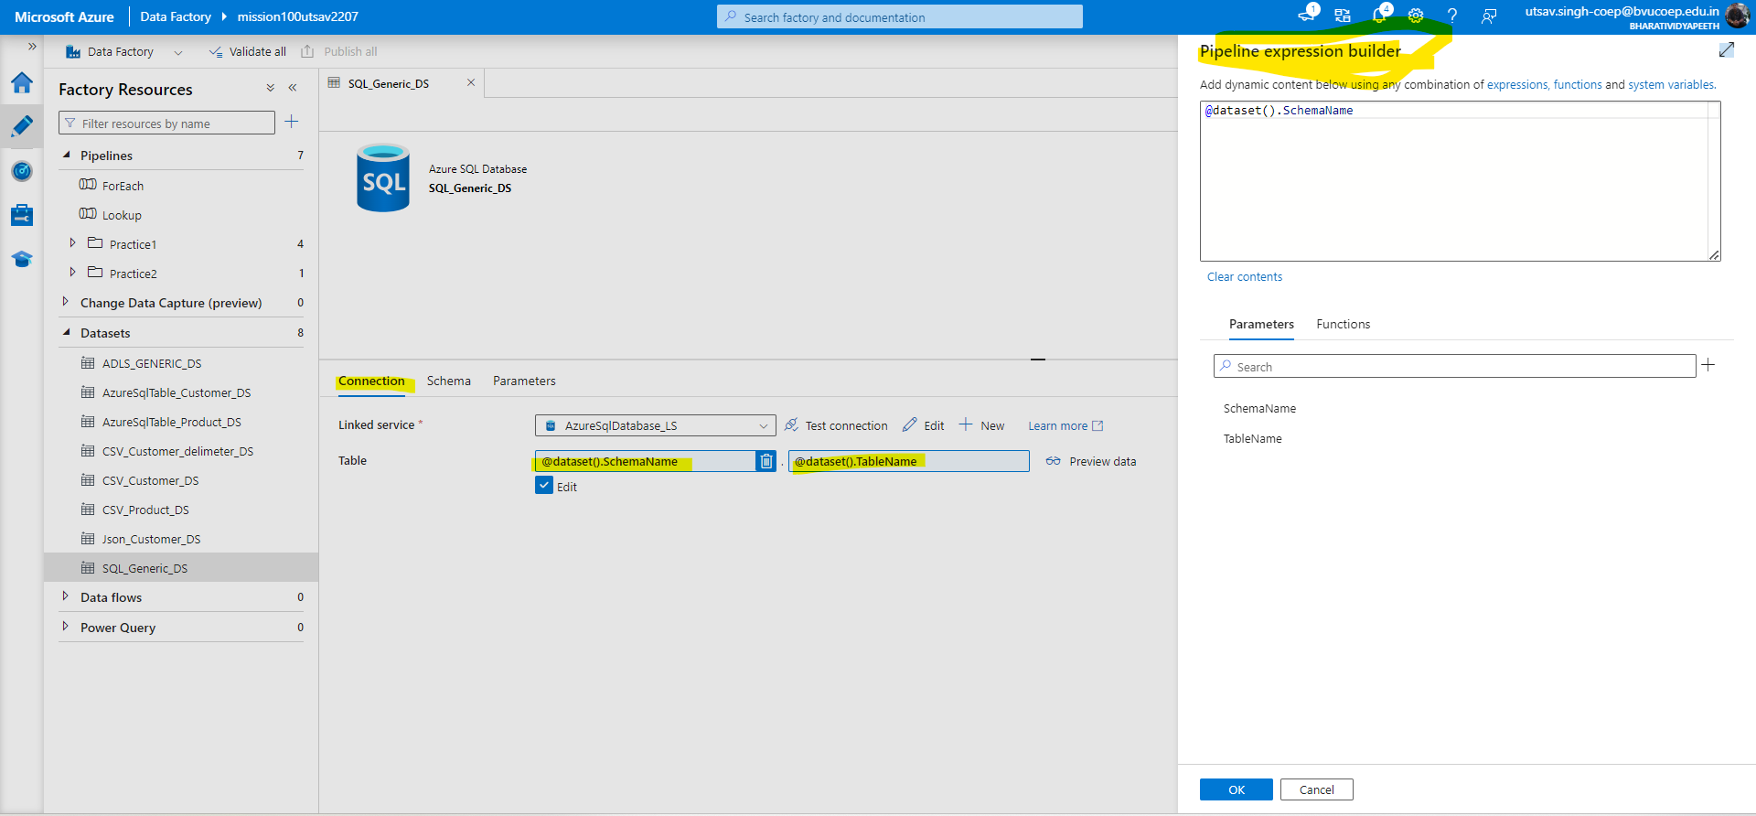

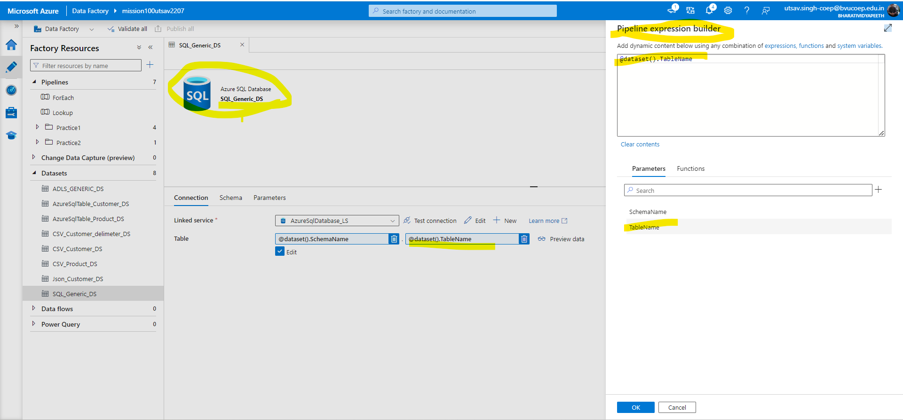

3.Now Create Generic Dataset for ADLS and pass the filepath parameter for folder generation when PL will succeed.

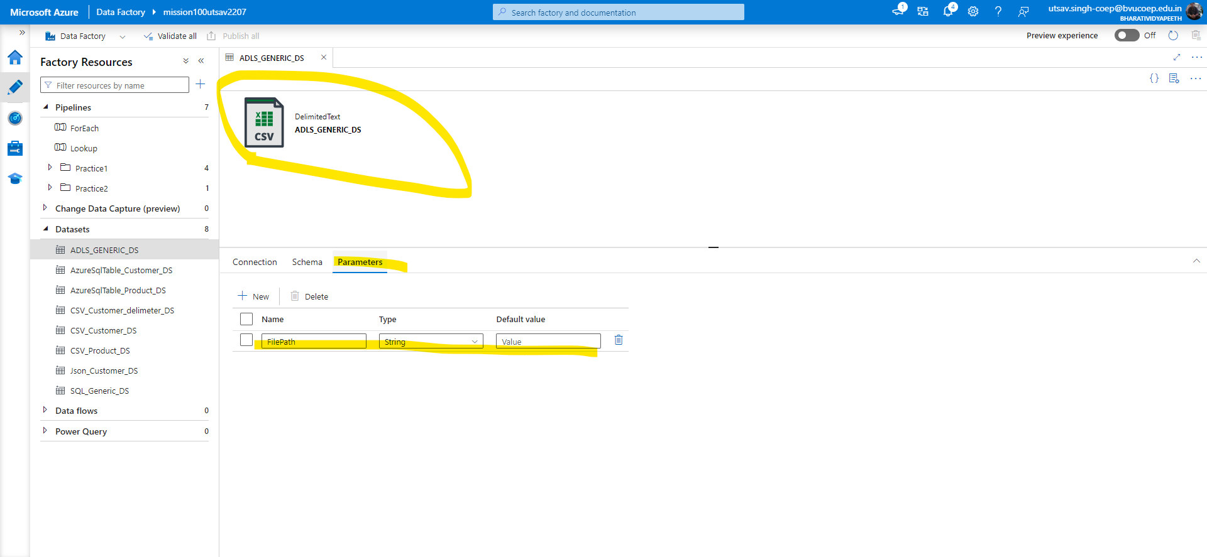

4. Now under the path click on dynamic content and select the parameter which you have created.

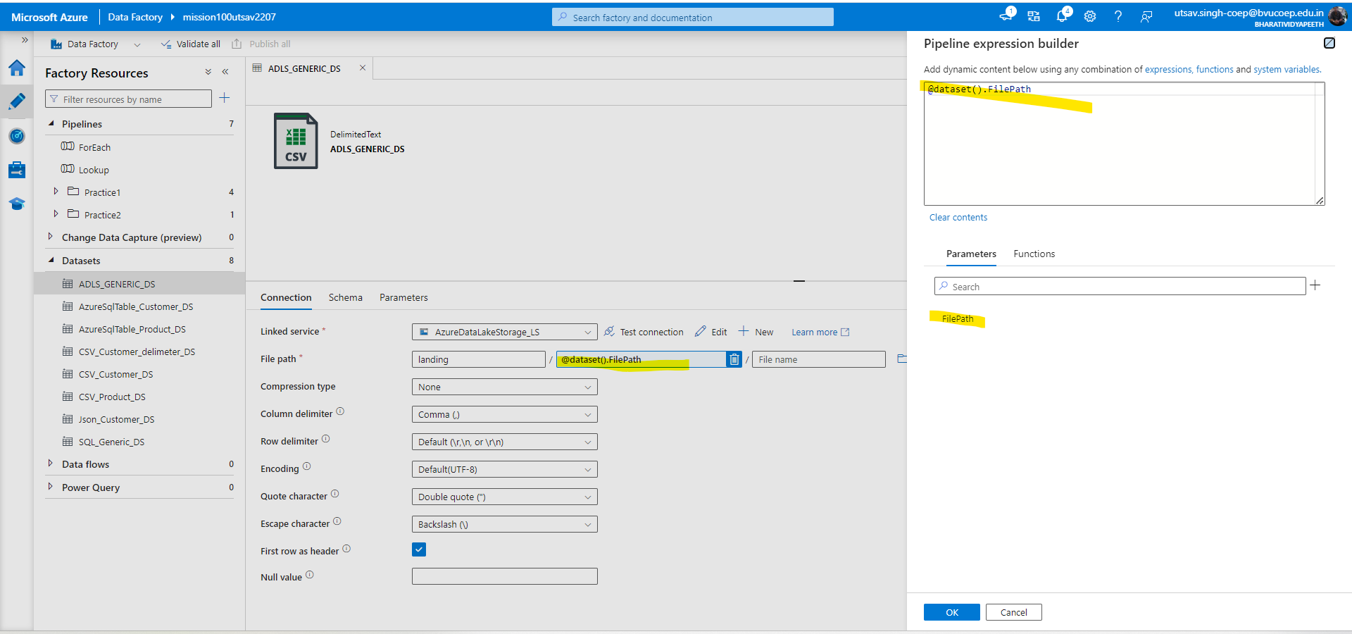

5. Create a new copy Activity there you select the source and give the schema and table name which you want from database and In sink give the file name for file generation given in the dynamic content and then check the path that whether the folder and file is there or not.

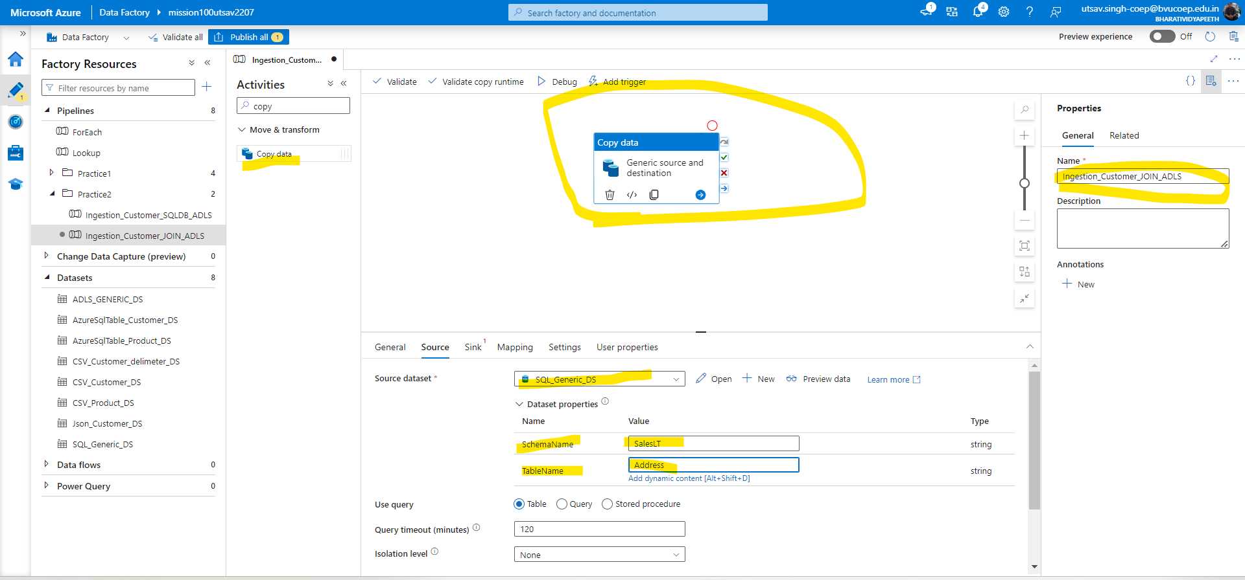

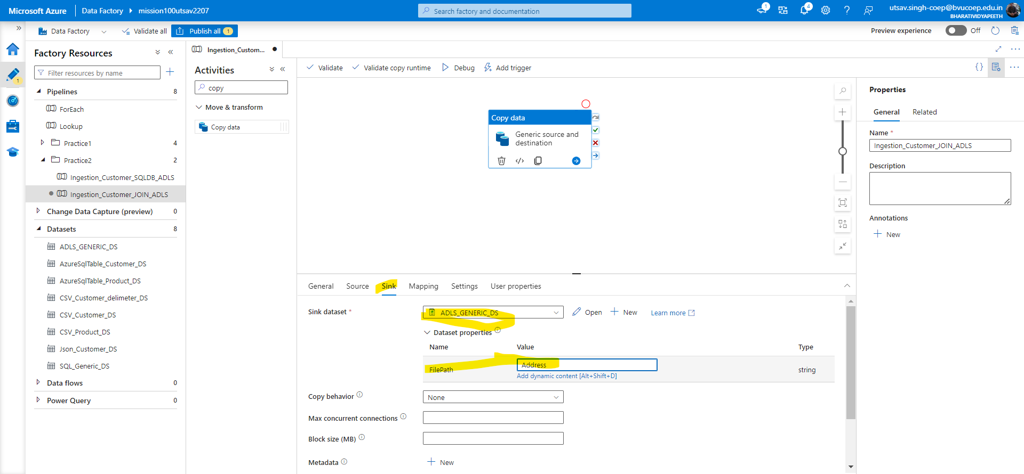

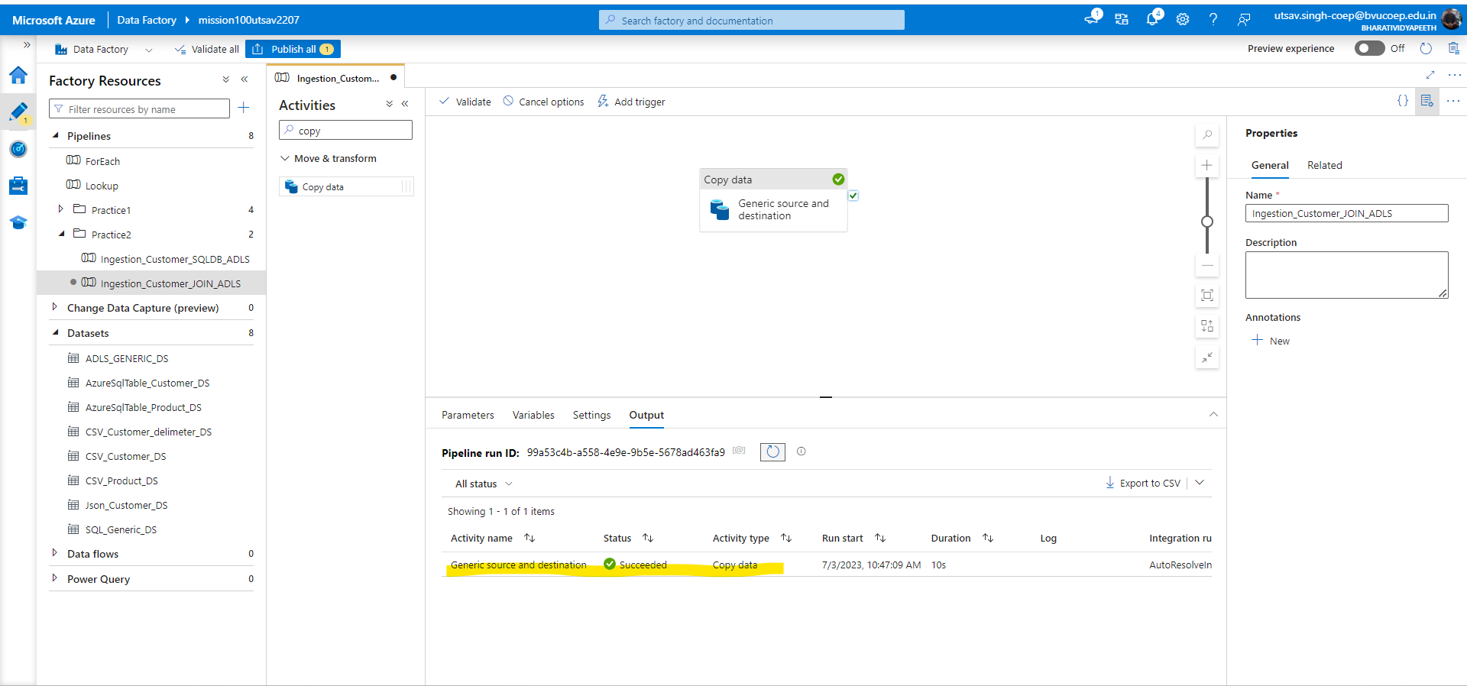

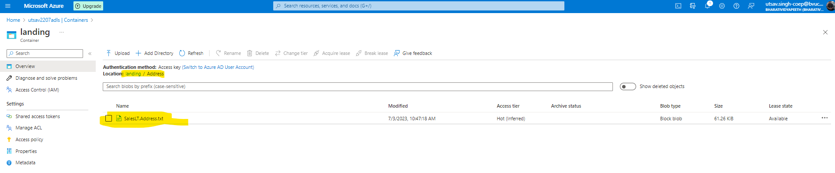

## Q 3. Create a Pipeline name 'Ingestion_Customer_JOIN_ADLS' which will copy the all the customer names along with their address into the csv. (Hint Join Customer+ Customer Address table)

Solution:- For multiple table we can create For each Pipeline.

* After that we will use create array function and use it as dynamic content in items section.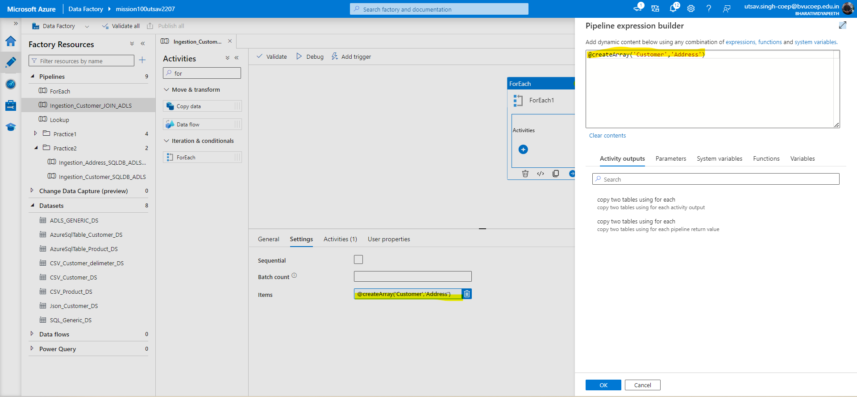
* Then create a copy activity under for each activity and in source give the source dataset and fetch the multiple tables in table name using dynamic content and In query type the query as per the requirement. Then in Sink give the file path value and check whether the given folder and pulled data is generated or not.

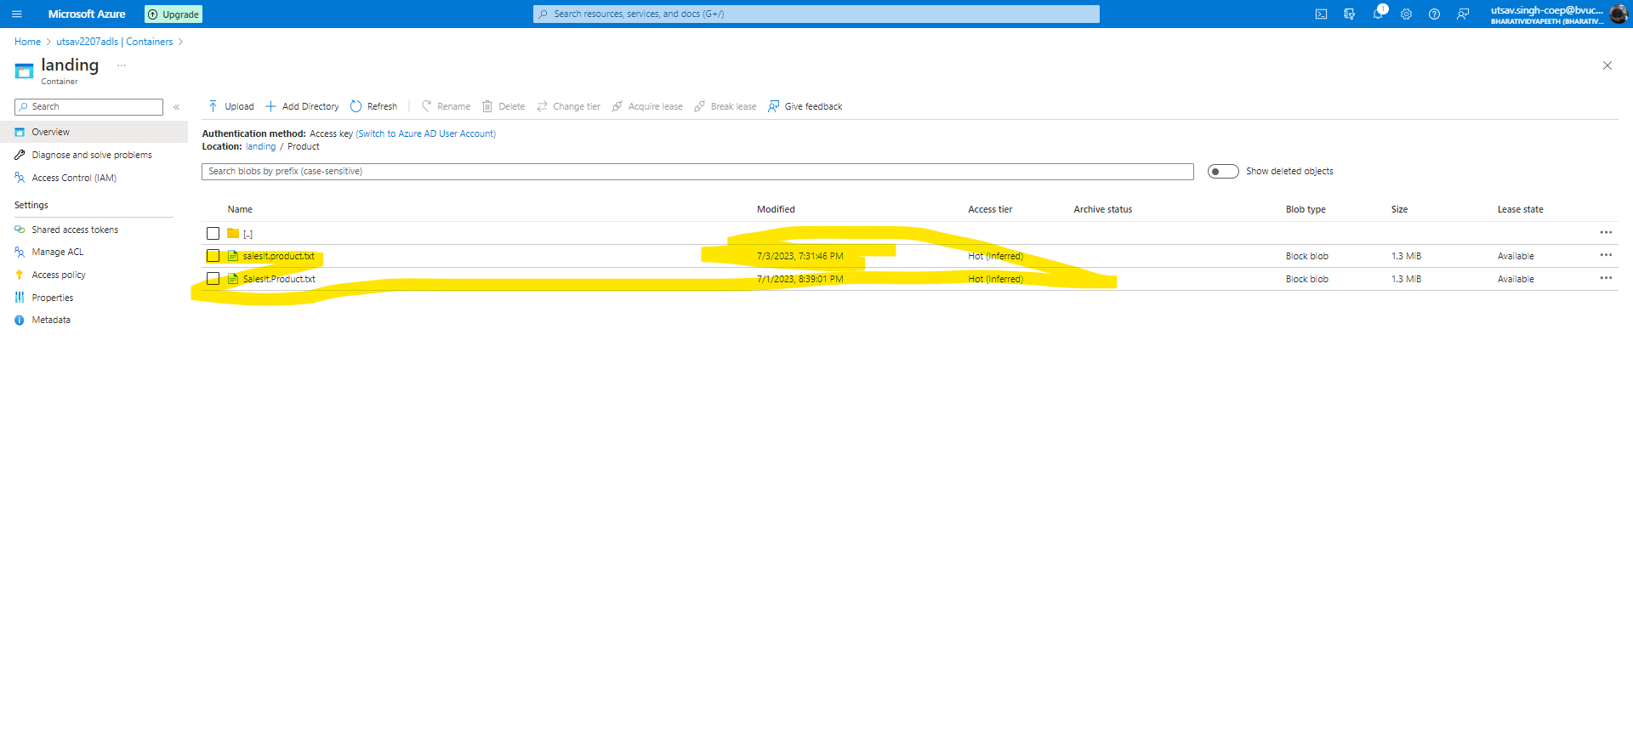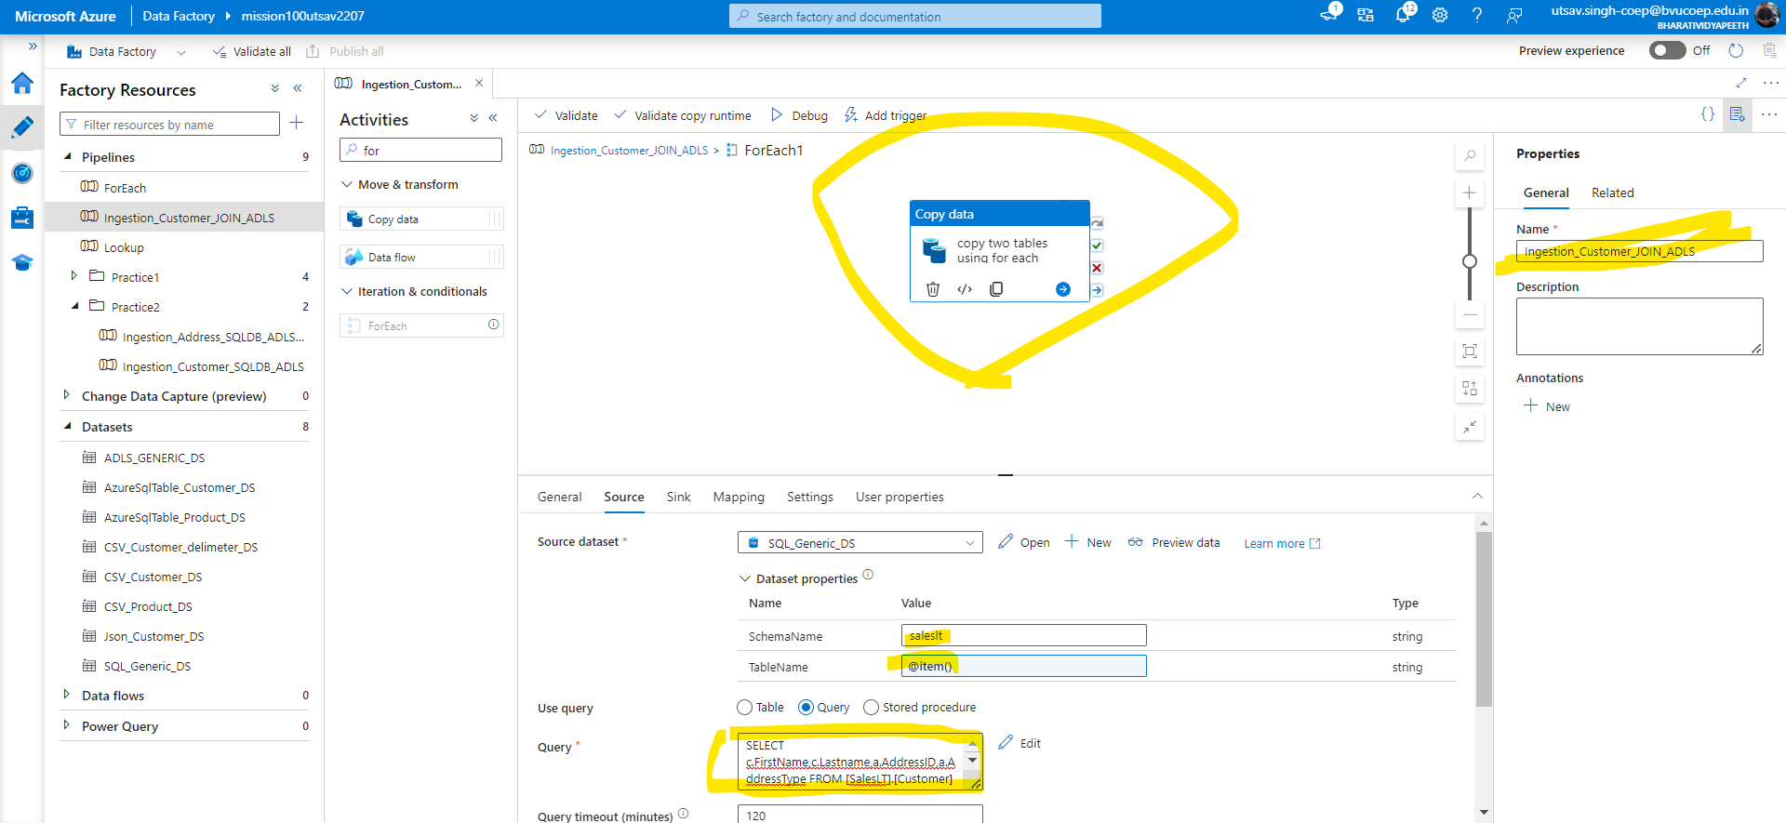

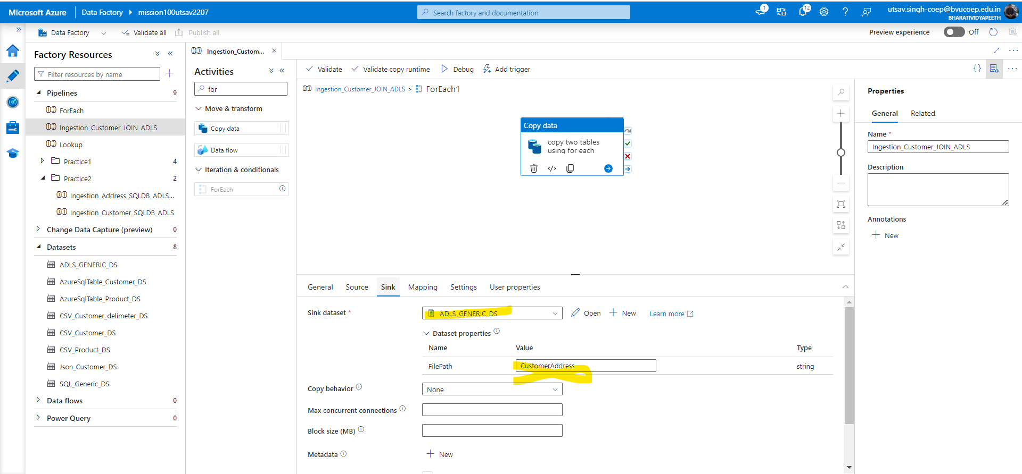

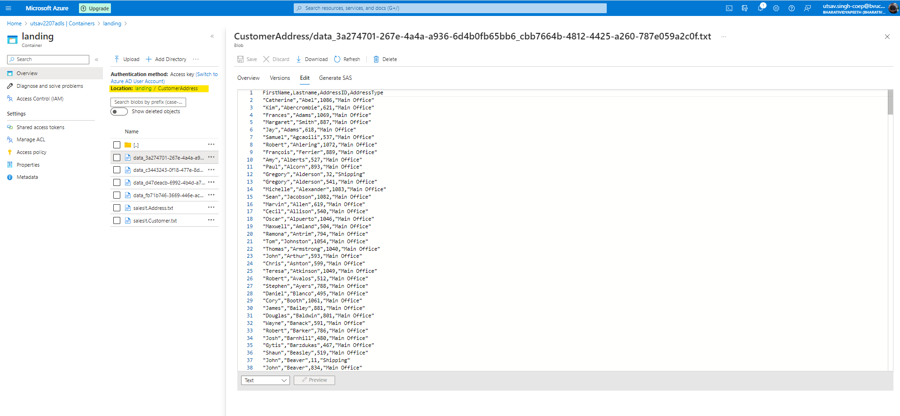

## Q 4. Create a pipeline name 'Ingestion_Product_To_JSON' which will copy all the product records as JSON only if total number of records >10.

Solution:- For this question first we have to create lookup activity which will use to look the values or fetch the required data by putting query in query tab and then after successful run check the output also we have to attach the dataset which we have to pull.

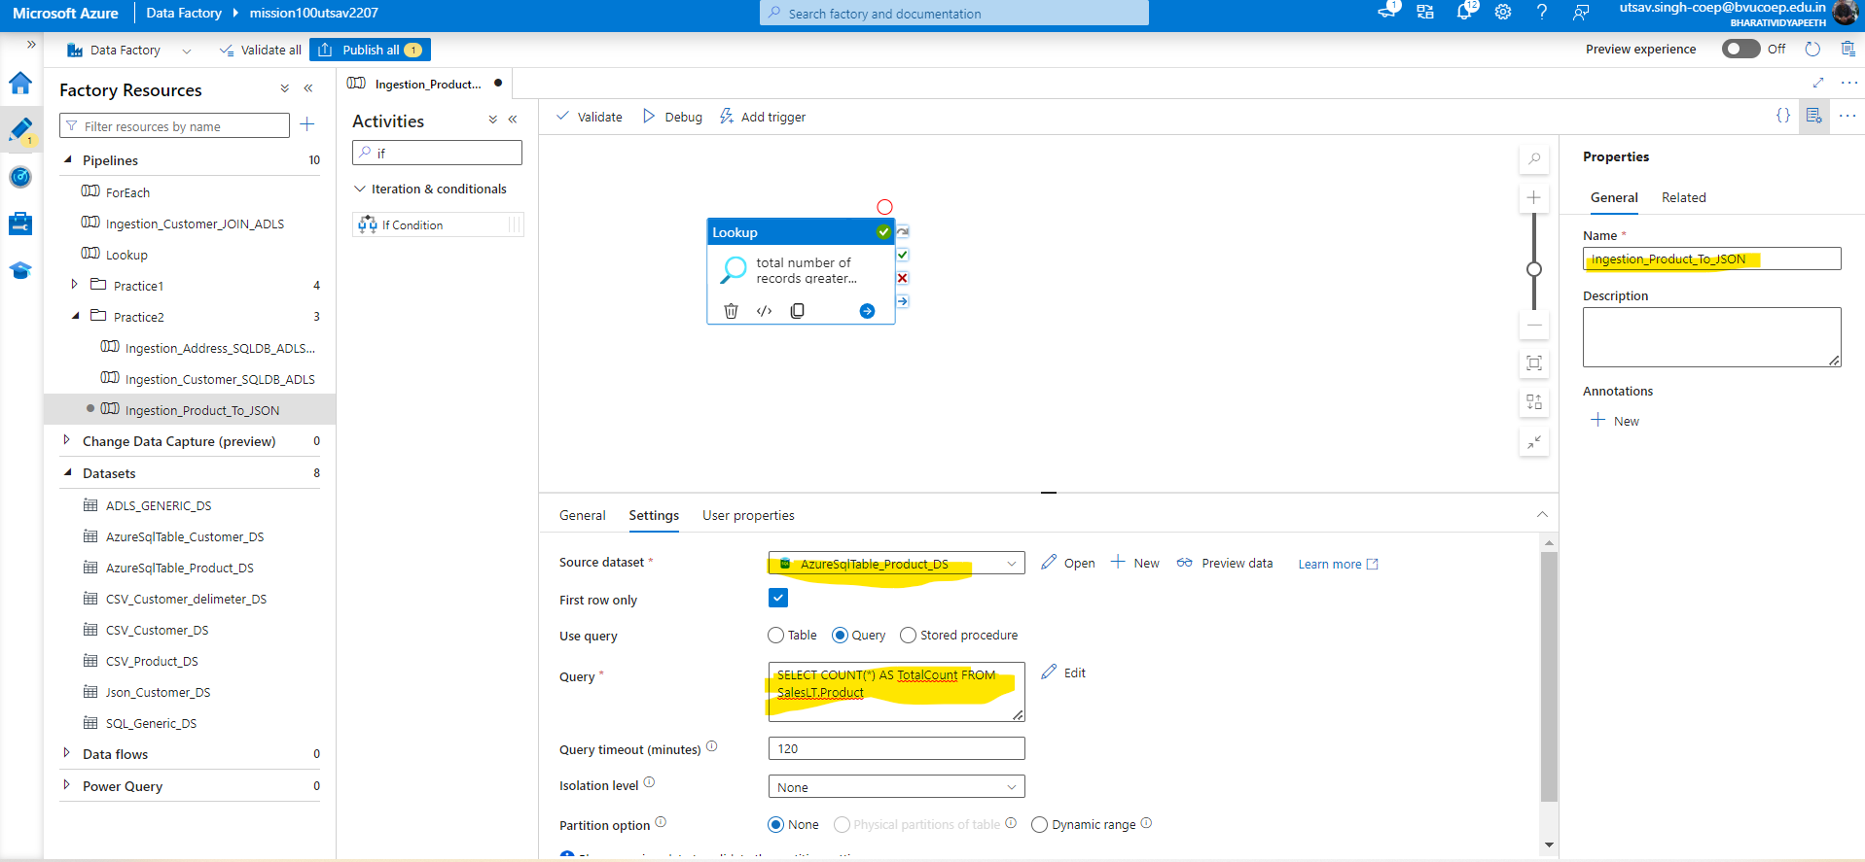

-Then copy the row column and total count aliasing from lookup activity output for further use in the condition in another If Pipeline.

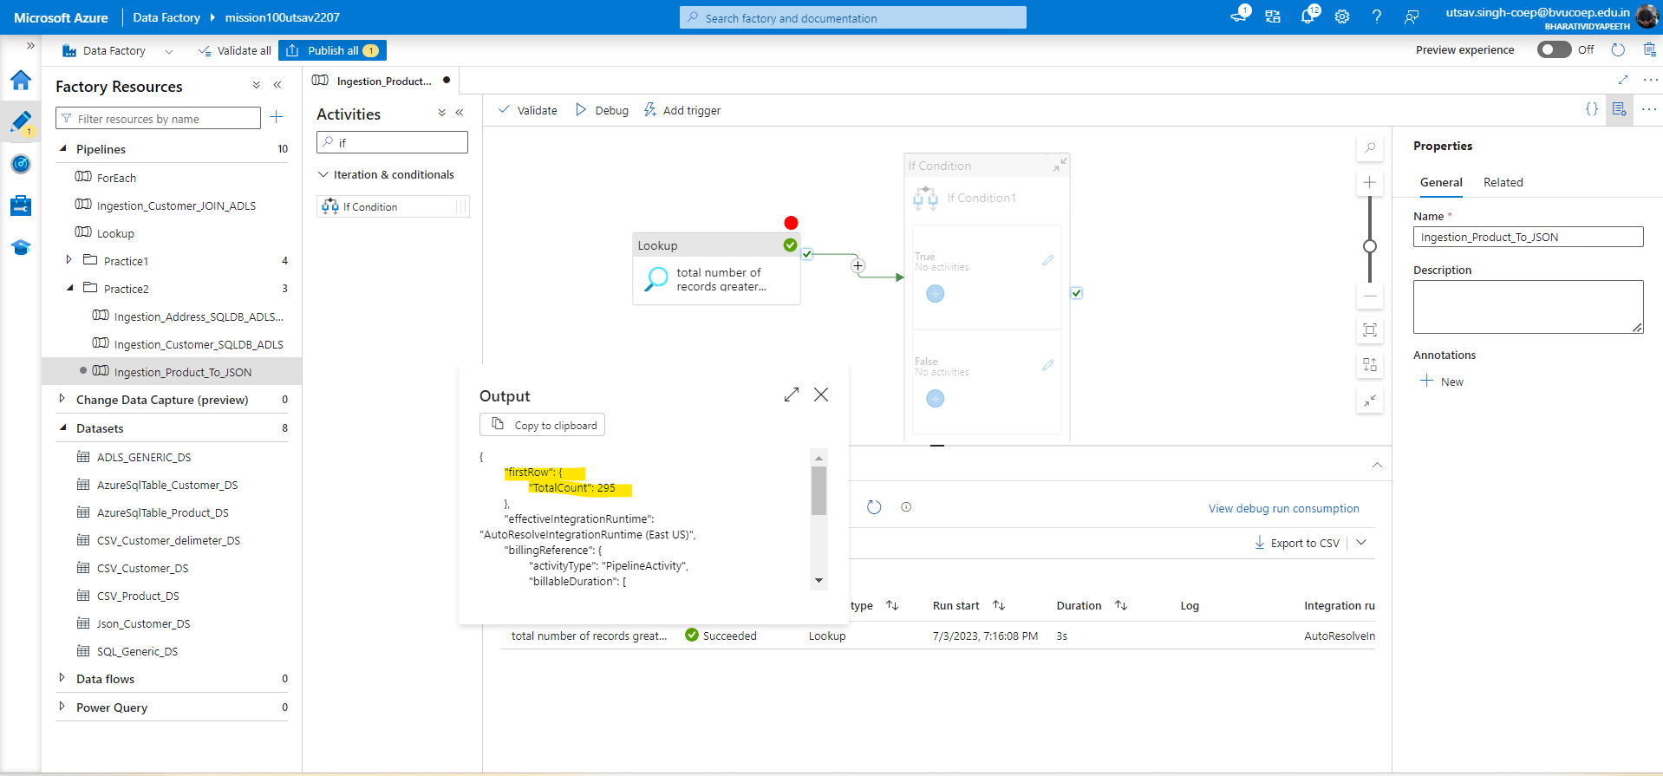

-Now Create If activity and then in expression section use function greater and check the activity output.

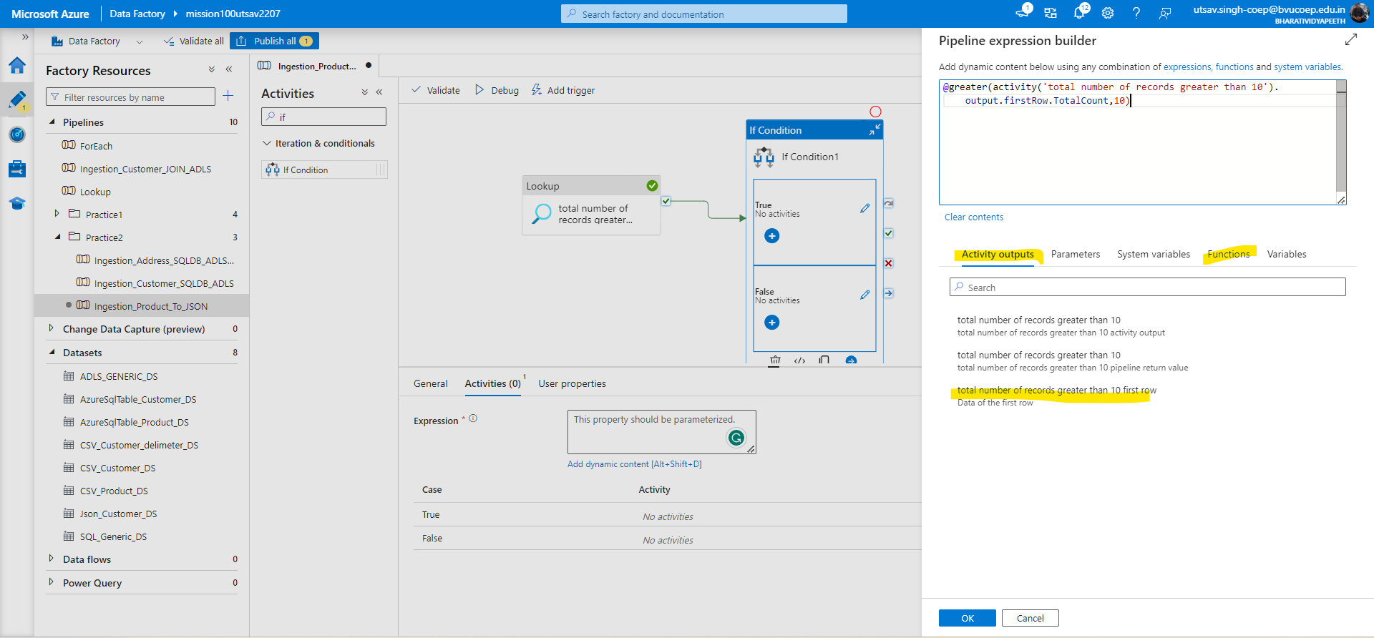

-Now in true condition create copy activity which will pull the product data from database and in destination it will generate the output.

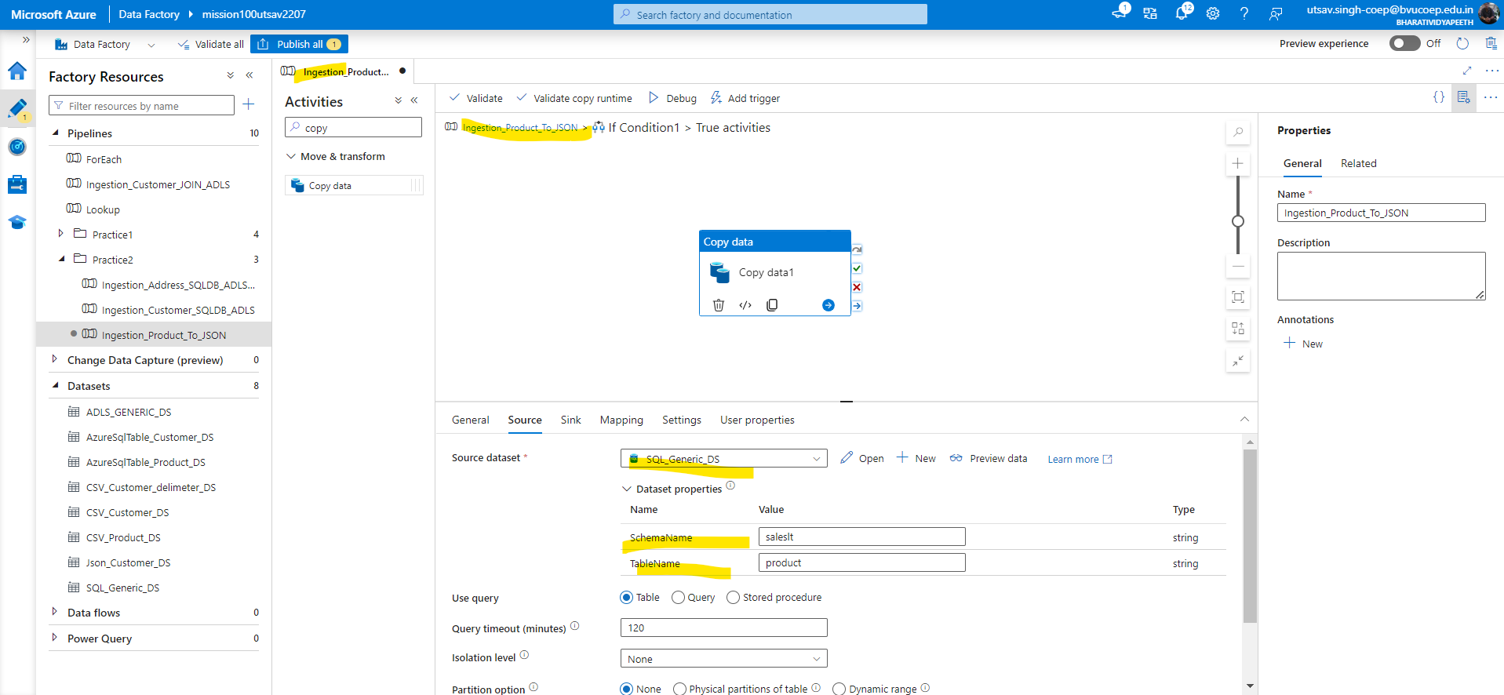

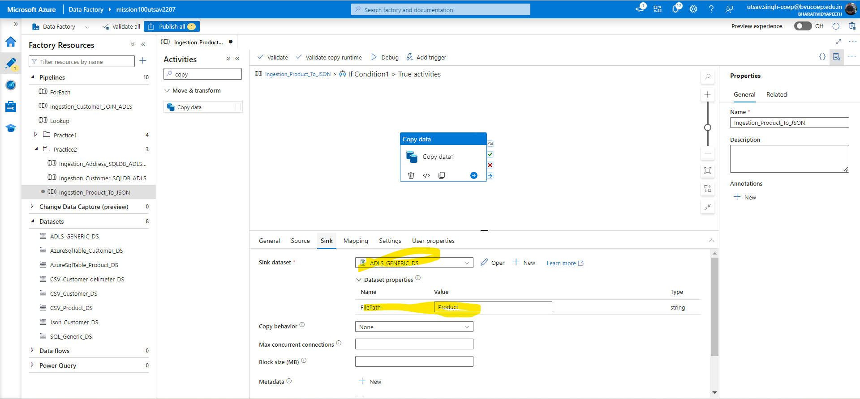

-And For Json data for product table we can create new dataset but for now we used generic dataset

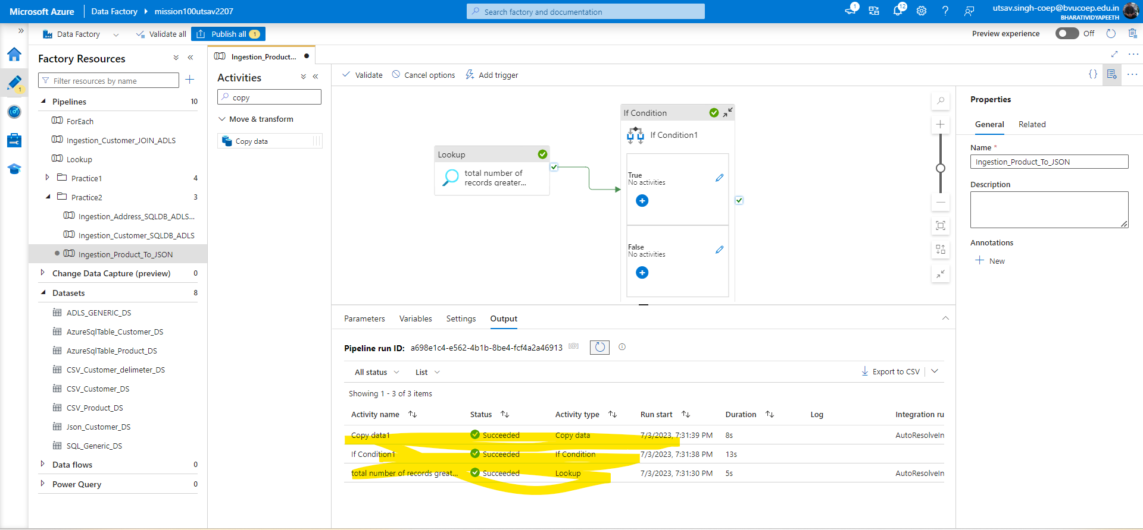

## Q 5. Create a pipeline name 'Ingestion_Product_Addres_To_JSON' which will copy all the product records as JSON only if total number of records >10. After that check total record count in address table if they are greater than 100 then copy the adress table data as CSV in ADLS.

Solution:- Already we have linked list and dataset we’ll go step wise. First create a lookup activity to check product data.

1.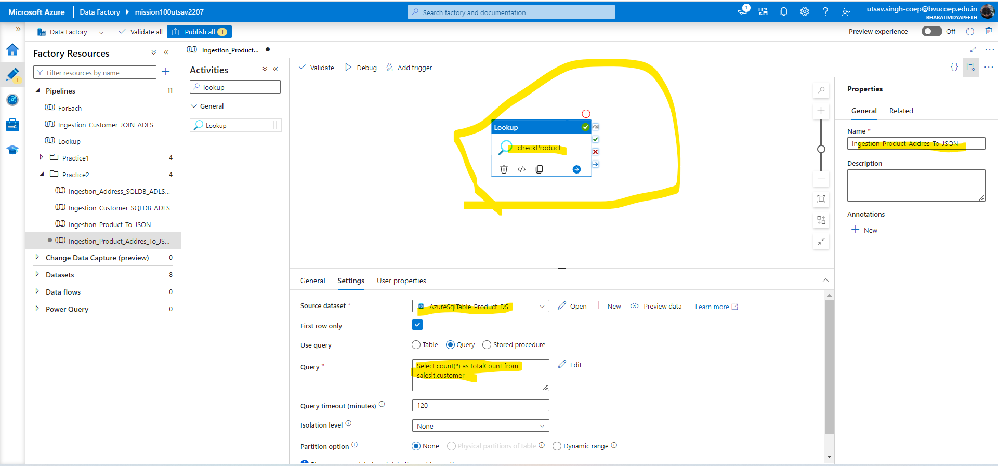

2.Now create if activity and give the condition in expression builder using grater function.

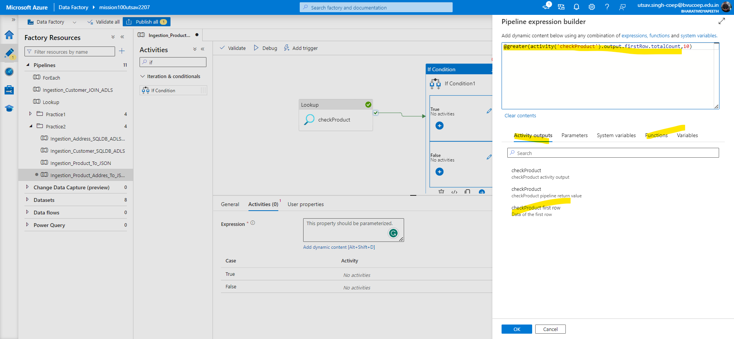

3.Under if activity create copy activity which will copy the data

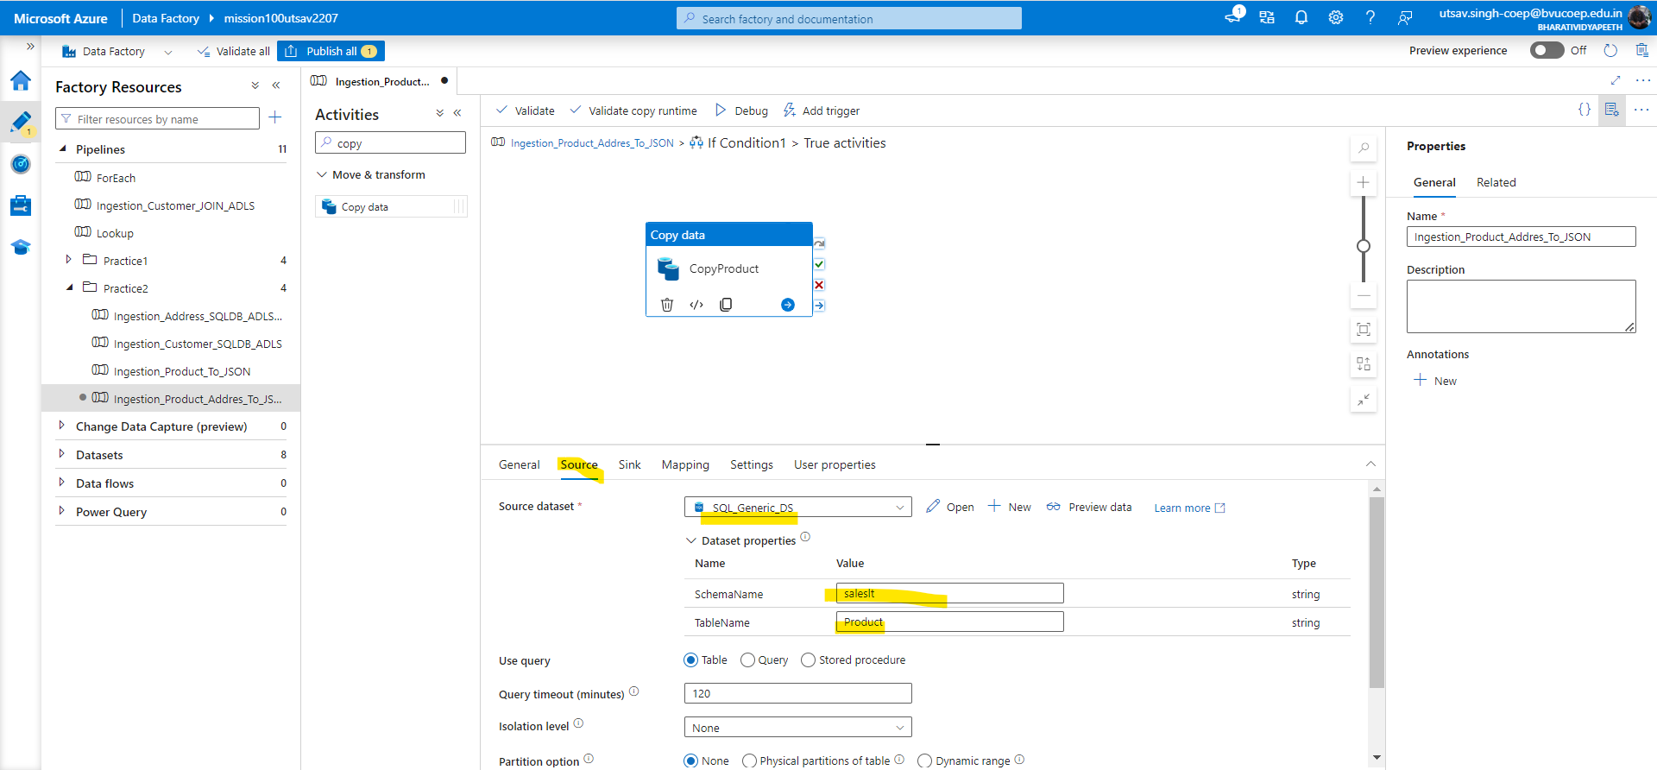

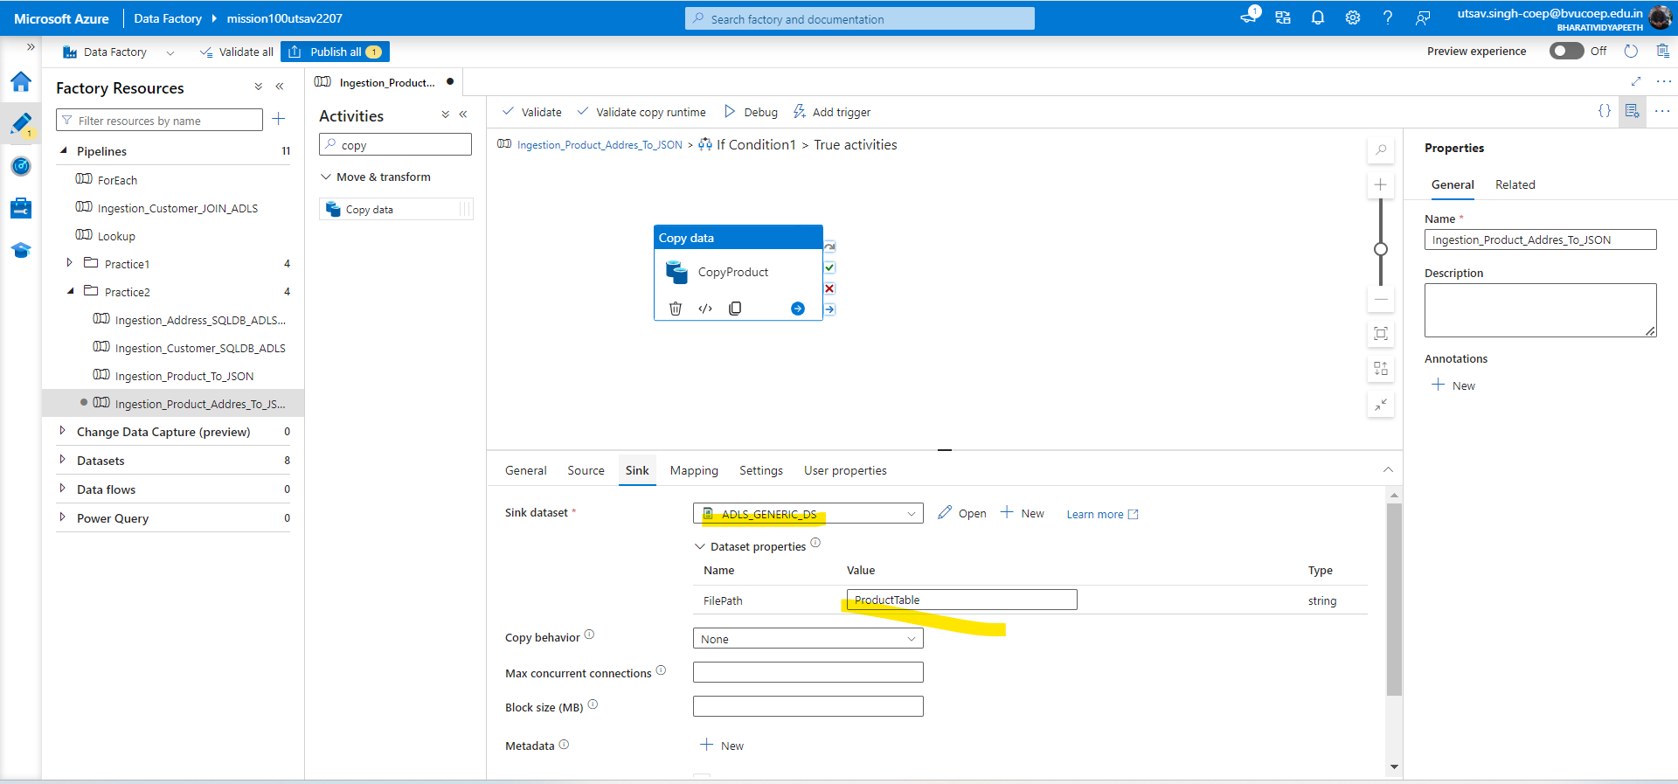

4.Now create a lookup activity for address check

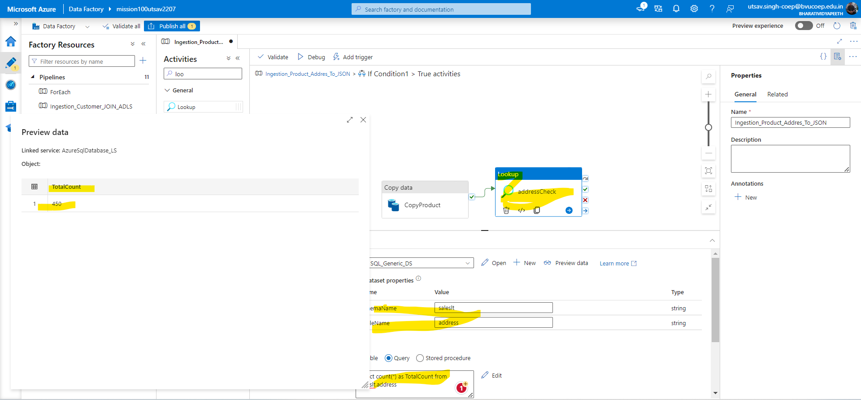

5.Now another if condition we have to addd and within nested loop it is not possible so we will recall if activity by creating executing pipeline. But for this first we have to create a If activity.And in Address child pipeline give the condition in if condition.And then create copy activity under if activity and give source and destination which you want to copy

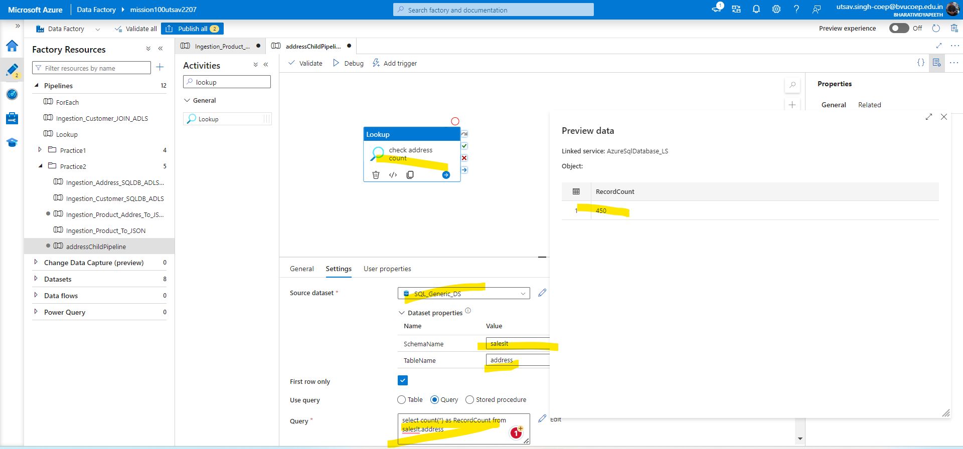

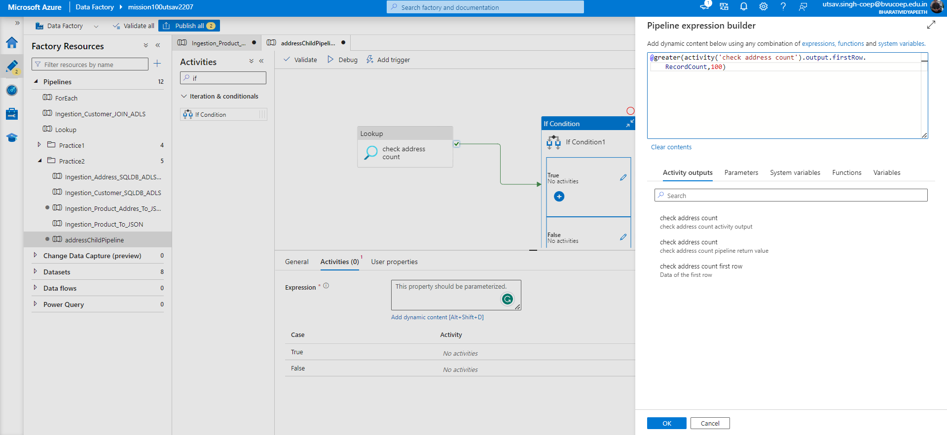

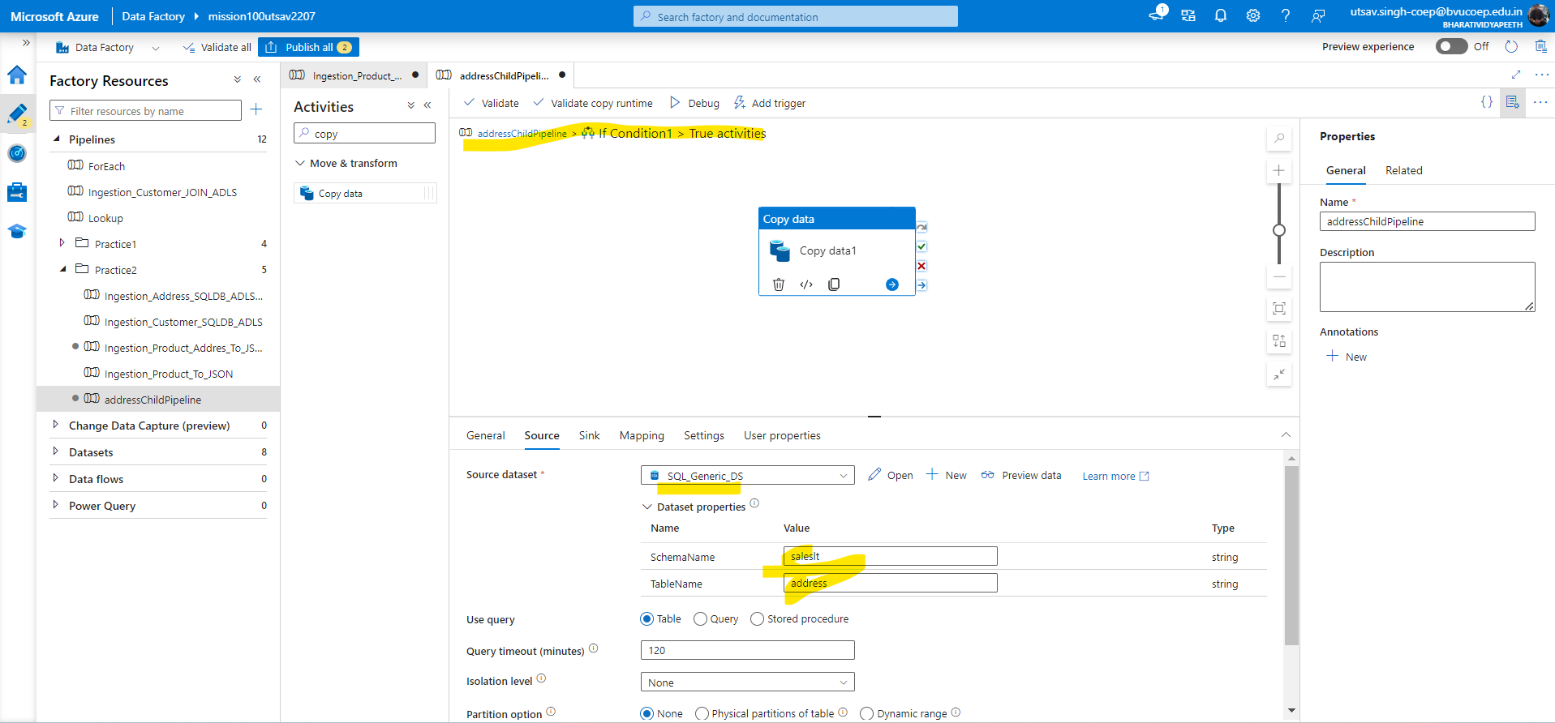

6. Now call the address child pipeline using execute activity in parent under the true condition.And in invoked select the PL which you want to invoke.

